Муниципальное бюджетное общеобразовательное учреждение Средняя общеобразовательная школа села Подольск муниципального района Хайбуллинский район Республики Башкортостан
РАССМОТРЕНО на МО СОГЛАСОВАНО УТВЕРЖДАЮ
________________ ________________ _________________
Гизулина Л.В. Магадеева Ф.А. Юнусов А.Р.
Руководитель ШМО зам. директора по УР директор школы

Экзаменационный материал для промежуточной аттестации по английскому языку за курс 7 класса

Учитель английского языка: Гизулина Л.В. высшая квалификационная категория

с. Подольск

ПОЯСНИТЕЛЬНАЯ ЗАПИСКА
К экзаменационным заданиям (билетам) промежуточной аттестации по английскому языку за 7 класс.
Количество билетов – 20.
Экзаменационные билеты составлены на базе тестовых заданий УМК «Английский язык Rainbow English 7», а именно – заданий выходного тестирования и промежуточного (модульного) тестирования.
Каждый билет состоит из трёх разделов:
1. Лексико-грамматический (Grammar);
2. Чтение (Reading);
3. Говорение (Speaking).

В лексико-грамматическом разделе представлено 15 заданий выходного тестирования (№№ 1-80) УМК «Английский язык Rainbow English 7». Учащимся предлагается заполнить пропуски в предложениях одним из трёх предложенных вариантов ответа.
Результат – 15 х 1 = 15 баллов

В разделе «Чтение» содержится текст, приблизительно 100 слов (задания модульного тестирования к которому прилагается 5 высказываний.
Учащиеся оценивают справедливость каждого высказывания, относительно содержания текста, отмечая его, как справедливое – «Т», или ложное – (F).
Результат –5 х 1 = 5 баллов

В разделе «Говорение» учащимся предлагается высказаться по одной из устных тем.
Результат: Скорость чтения – 1 балл
Произношение – 1 балл
Интонация – 1 балл
Обоснование одного из ответов – 2 балла
= 5 баллов

Итого, результат экзамена – 25 баллов

Процедура экзамена:
Каждый учащийся выполняет задания одного, случайно им выбранного билета.
– Выполнение заданий №№1, 2 и подготовка устного ответа – 30 минут.
– Выполнение раздела «Говорение» – 5 минут.

3. ТЕКСТЫ ДЛЯ УЧИТЕЛЯ
выполнения заданий №2 (Чтение)

2. Reading. Билет № 1/9/17
IntheUnitedStatesthere’saburglaryalmostevery fifteen seconds, especially during the day when people aren’t at home. But don’t be afraid. There are a lot of things you can do to protect your house from burglars.
First of all, you shouldn’t let people you don’t know into your home. You should always look through the peephole before you open the door. It’s also a bad idea to leave money, jewelry or keys next to windows.

1. In the USA there’s a burglary almost every fifteen seconds. …………..
2. There are a few things you can do. …………..
3. You shouldn’t let strange people into your home. …………..
4. Never look through the peephole. …………..
5. Don’t leave money near windows. …………..

2. Reading. Билет № 2/10/18
Another way to protect your home is to make it look busy all the time. Leave the radio on when you are away and fit dusk-to-dawn lights in the garden. That way, anyone watching the house will think that someone is there.
Call the police the moment you see something unusual in your neighborhood. And remember: never put up a fight with a burglar. Just hand over your valuables and then call the police. It’s better to be safe than sorry.

1. Make your home look busy all the time. …………..
2. Always switch off the radio. …………..
3. Fit dusk-to-dawn lights in the garden. …………..
4. Never call the police. …………..
5. Don’t put up a fight with a burglar. …………..

2. Reading. Билет № 3/11/19
When I was seven years old, my family left the big city and moved to the countryside. I was very excited because our new house was near a beautiful forest.
One day, I decided to go for a walk in the forest but I lost my way. I tried to get back but I just went deeper into the forest. I looked around me and started calling for help, but no one heard me. I was confused and scared because it was almost dark, so I sat under a tree and began to cry.

1. My family moved to the countryside …………..
2. Our new house was near a beautiful river. …………..
3. One day, I lost my way. …………..
4. I looked around me and started singing. …………..
5. I sat under began to cry. …………..

2. Reading. Билет № 4/12/20
I looked around me and started calling for help, but no one heard me. I was confused and scared because it was almost dark, so I sat under a tree and began to cry.
Suddenly I heard someone coming. It was a boy my age. “Hi,” he said. “I’m Philip. What’s the matter?” I told Philip that I was lost. “Don’t worry,” Philip said. “I live near here. I know the forest well.” We walked and talked until we were out of the forest. Philip said goodbye and left before I could thank him.

1. I started calling for help. …………..
2. I sat under a tree and began to sing. …………..
3. Suddenly a boy my age came to me. …………..
4. The boy’s name was Panty. …………..
5. I didn’t thank the boy. …………..

2. Reading. Билет № 5/13/
When I got home my mum was talking to a policeman. They were both very upset. “Oh, Tom, thank
goodness you’re OK!” my mum said when she saw me. “I lost my way in the forest, Mum, but I’m fine now. I’m so sorry.” I said. “You were lucky, young man,” the policeman said. “Never play alone in that forest, it’s too dangerous. Eight years ago, a young boy named Philip MacMann lost his way in that same forest and never came back.”

1. My mum was talking to a policeman. …………..
2. I lost my way in the city. …..………
3. It’s dangerous to play in the forest. …..………
4. Ten years ago a boy lost his way in the forest. .……….…
5. Philip MacMam didn’t come back. …..………

2. Reading. Билет № 6/14/
The person I admire the most is Leonardo da Vinci. He was born on 15th April 1452 in the town of Vinci, Italy. His full name was Leonardo di ser Piero da Vinci, which means Leonardo, son of Piero from Vinci. He was not only one of the greatest painters of all time, but he was also an architect, sculptor, engineer, inventor, mathematician and musician.
Leonardo da Vinci was a very intelligent and imaginative man. He created many different designs. Some of them were for a bicycle, a helicopter, a parachute and even an aeroplane!

1. My favourite person is Leonardo da Vinci. …………..
2. He was born on 15th August 1452. …………...
3. He was one of the greatest painters of all time. …………...
4. He was not a musician. …………..
5. Leonardo da Vinci was a clever man. …………...

2. Reading. Билет № 7/15/
Leonardo da Vinci paid a lot of attention to detail and his paintings are very realistic. The Mona Lisa, for example, is one of his best known works of art. It is a painting of a woman whose face often makes people wonder if she is smiling or not.
I admire Leonardo da Vinci for his amazing works of art and his great inventions. His artwork will last forever and people around the world admire it even today.

1. Leonardo da Vinci’s paintings are very realistic. …………..
2. The Mona Lisa is one of his best known songs. …………..
3. The woman makes often people wonder. …………..
4. Leonardo da Vinci doesn’t have works of art …………..
5. His paintings will live forever …………..

2. Reading. Билет № 8/16/
On 12th June, a ‘Fun Run’ took place in the town of Sunnyfield. A group of sixteen-year-old students from the local high school came up with the idea and over 500 people of all ages took part. Luckily, it was a sunny day. Everyone had fun running, walking or skate-boarding the 10-mile distance. Thanks to the event, £2,346 was raised for the charity ‘Cancer Care’.
Suzie Hamilton, one of the students who organised the run, said, “We wanted to do something useful for others and this seemed the most fun thing to do.”

1. Fun Run’ took place in June. …………..
2. A group of students took part. …………..
3. The weather was sunny. …………..
4. Everyone had a 15-mile distance. …………..
5. Suzie Hamilton organised the run. …………..

4.ЭКСПЕРТНЫЙ ЛИСТ УЧИТЕЛЯ
(экзаменатора) промежуточной аттестации по английскому языку в 7__ классе

№ | ФИО | Билет № | Задание 1  15 баллов | Задание 2  5 баллов | Задание 3 |  |  |  | Итого  25 баллов
 |  |  |  |  | Скорость  чтения  1 балл | Призношене  1 балл | Интонирова-ние  1 балл | Обоснованый ответ  2 балла
1
2
3
4
5
6
7
8
9
10

Учитель ______________ / ____________________ / « ___»________ 20___ г.
6. КЛЮЧИ К ЗАДАНИЯМ
6.1. Ключи к вопросам задания №1 (Лексика-грамматика):
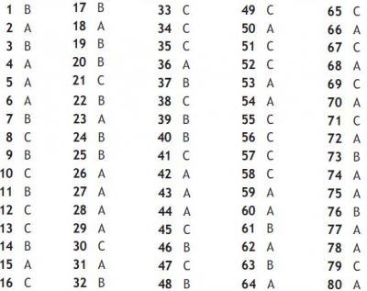
6.2. Ключи к вопросам задания №2 (Чтение):
1 – T; 2 – F; 3 – T; 4 – F; 5 –F

7. БИЛЕТЫ С ЗАДАНИЯМИ
Пояснение. В пакете под номерами 1-20 находится 8 билетов для учащихся, каждый из которых представлен по 3 раза. При каждом последующем представлении, к номеру билета необходимо прибавить число 8. 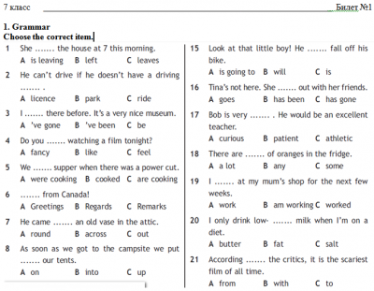

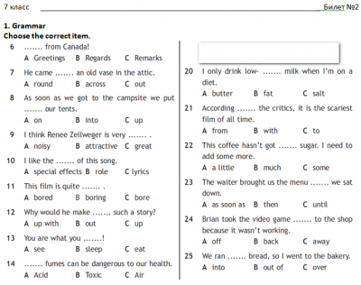

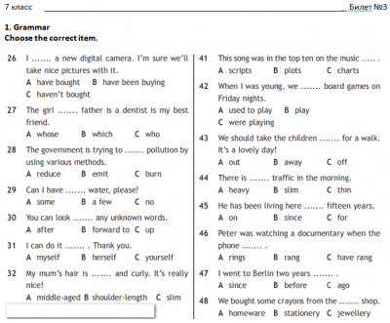

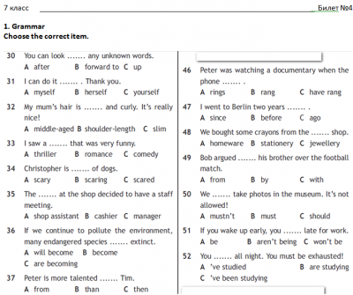

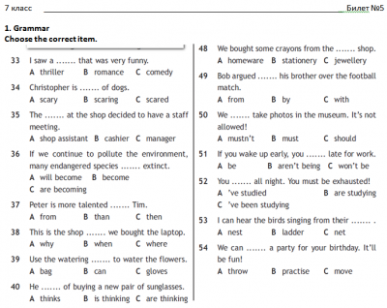

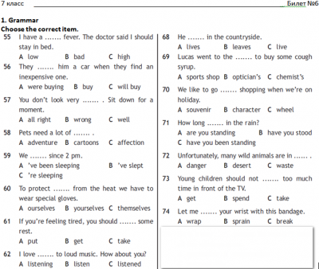
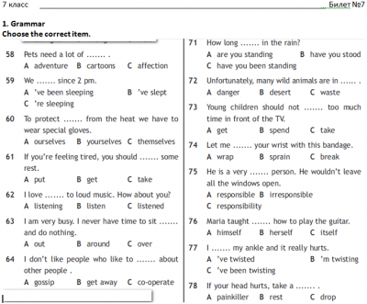

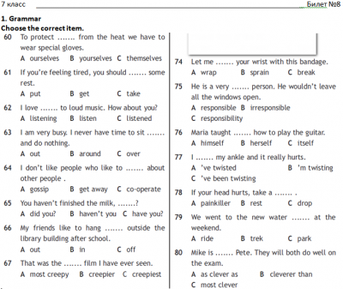
3.Speaking
Билет№1/10 . About Myself
Билет №2/11 My Family.
Билет №3/12 .Environment and Pollution
Билет № 4/13 .Keeping feet.
Билет № 5/14 My School
Билет № 6 / 15 Pupil’s Day
Билет № 7 /16 English- the language of the Planet
Билет № 8 /17. Flora and Fauna of Russia
Билет № 9 /18 .The UK.
Билет № 19/ 20 London.

